***TITTLE:INTERACTION MODELS***

The software compromises of three major interactions which are;

->user and system Interaction

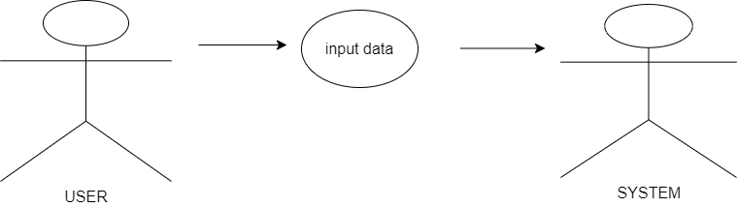

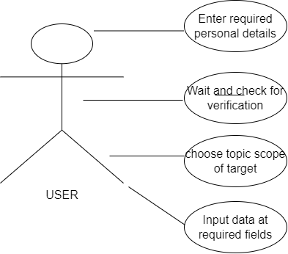

**->System and System Components Interactions**

**Sequence diagram;**

